WORD 101 – Insert a Picture

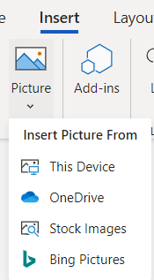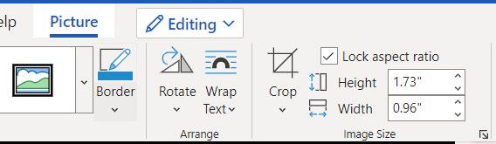
Using the options from the “Insert -> Picture” tab insert a picture from Bing, and from a Stock image. Then follow the directions in each square for the formatting you need to do to it.
Insert Picture from Bing. | Resize picture so that it fits in this square. (Use the corner handles so it resizes keeping the same ratio.) | Add a BLUE border with WEIGHT = 2.25 pt DASHES = Round Dot | Insert Picture from “Stock Images”. | Resize picture so it about half the size of this square and fits in the middle. (This can be done by adding spaces above the picture and using the “centre justify” button). | Apply a PICTURE STYLE of choice.
Insert Picture from Bing. | Resize picture so that it fits in this square. (Use the corner handles so it resizes keeping the same ratio.) | Add a PURPLE border with WEIGHT = 4.5 pt DASHES = Dash | ROTATE the picture -> Flip HORIZONTAL | Use the picture below. | Crop the picture to just to the top and bottom of the words (no space above and below). | Move the picture to the top of the square. | Put a GREEN DASH border with weight 2.25pt.  Place your cursor under the thank you message. Insert a second picture from BING or STOCK IMAGE of something you are thankful for. | Resize so it fits under the “Thank You” phrase. | Apply a picture style of choice. | Type in what you are thankful for.

