Students Editing Content in Scholantis Blogs

Click on the links below to access information on how to customize the look of the blog and how to add/edit content within the blogs.

​Blog Settings | ​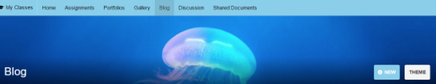
Formatting Ribbon | 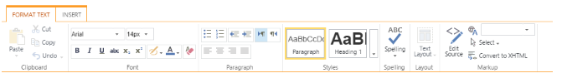
​Using the Insert Ribbon | ​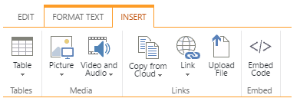
Inserting a Picture | 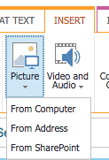
Inserting a Video | 