Internal Condom

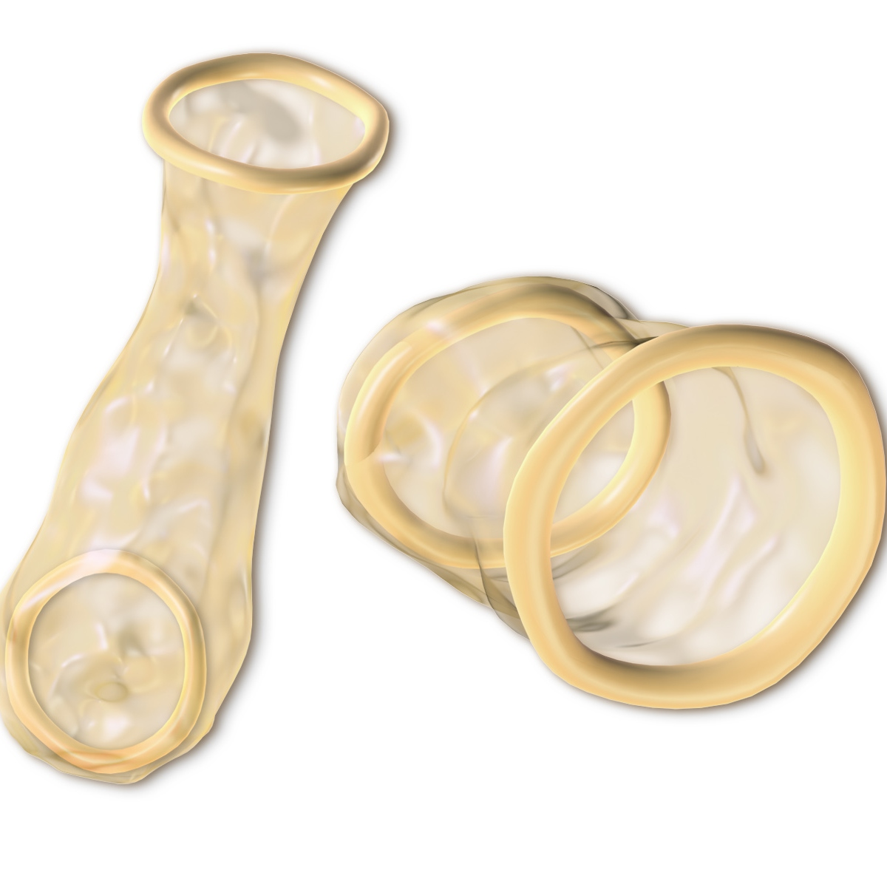
An internal condom is a soft, loose-fitting polyurethane (synthetic rubber or latex free) pouch. It has two flexible rings. When inserted, the smaller ring fits inside the vagina or anus. The inside of the condom is lubricated.
Dental/Oral Dam

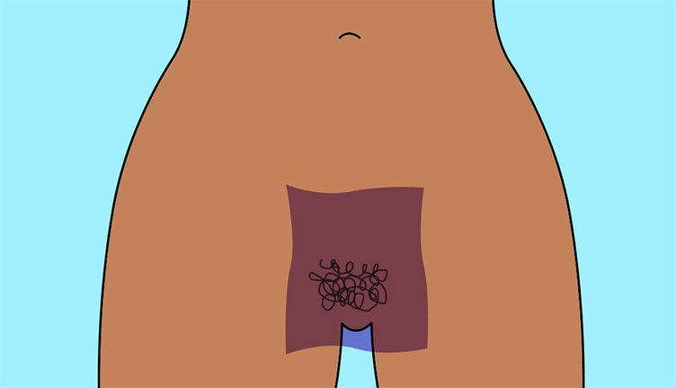

A dental/oral dam is a thin, flexible piece of latex that protects against direct mouth-to-genital or mouth-to-anus contact during oral sex. This reduces your risk for sexually transmitted infections (STIs) while still allowing for clitoral or anal stimulation.
Biological Male Reproductive System

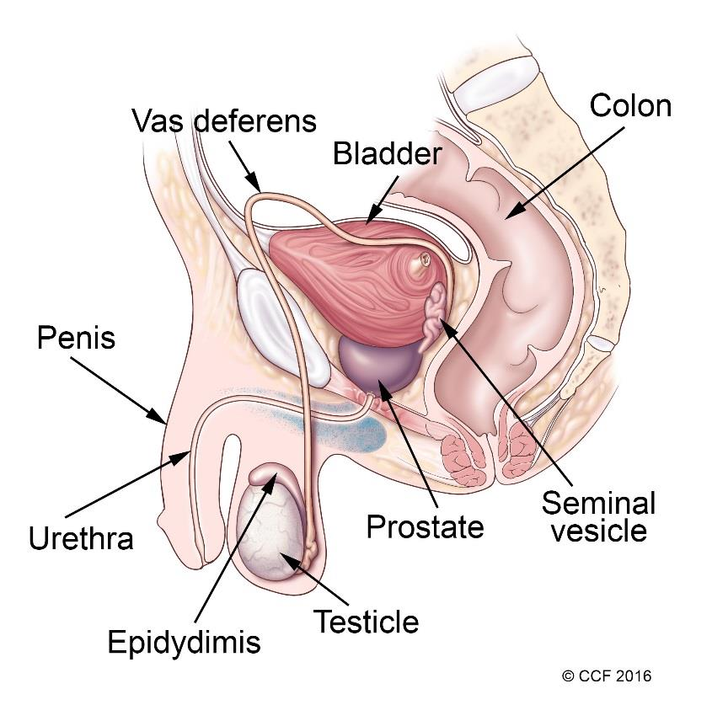
The male reproductive system is mostly located outside of the body. These external organs include the penis, scrotum and testicles. Internal organs include the vas deferens, prostate and urethra. The male reproductive system is responsible for sexual function, as well as urination.
Biological Female Reproductive System

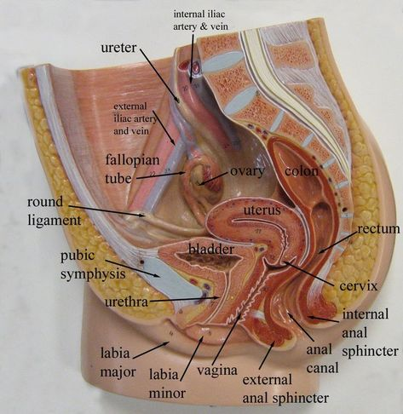

The female reproductive system includes all of the internal and external organs that help with reproduction. The internal sex organs are the ovaries, which are the female gonads, the fallopian tubes, two muscular tubes that connect the ovaries to the uterus, and the uterus, which is the strong muscular sack that a fetus can develop in.

