Word 101 – Format the Text

Read each line below. Use the tools from the ribbon to change the text according to what the instructions state. Triple click in each row to select the text OR Click hold and drag the mouse/cursor over the text.
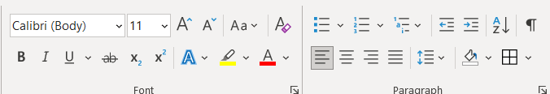
Make me font style Bodini MT Black
Make me bold
Centre align me
Left align me
Make me size 24
Make be red
Highlight me yellow
Underline me.
Copy this line. Press Enter. Paste underneath. Bullet the text.
Make me pink (select “more colours” from the colour palatte)
Make me italics
Make me Comic Sans
Make me size 8
Copy this phrase. Paste beside the phrase in the first line.
Make me blue AND underlined AND Cambria (font style)
Make me green, me italics, me Arial Black
(only change the actual word that represents the font change – ie change “green” to colour green.)
Make me 12, me bold, me highlighted green
Sally
In the space below, type your first name. Using the font formatting you did above, “stylize” your name. Change individual letters to various fonts, sizes and colours. When done, centre justify it.

