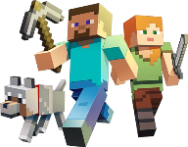
MINECRAFT LITERARY ELEMENTS STORYBOARD PLANNING
Sketch SiX elements from your novel – ONE must be a CHARACTER. Create a diary post that describes
the character’s encounter/interaction with this element (from YOUR point of view OR the main character’s point of view).
Element: | Element: | Element:
Sketch: | Sketch: | Sketch:
Diary Entry: | Diary Entry: | Diary Entry:
Element: | Element: | Element: Character -
Sketch: | Sketch: | Sketch:
Diary Entry: | Diary Entry: | Diary Entry:

