Backward Design Unit Planning Template:
 | Subject Area(s): | Planning Team:
Big Idea |  | Unit Guiding Question(s):
Content Goal | 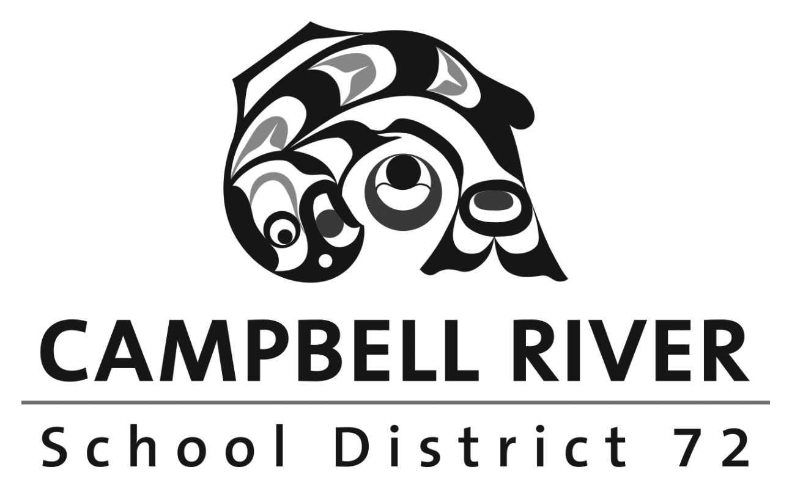  I know…
Curricular Competency Goal | I can…
Curricular Competency Goal | I can…
Curricular Competency Goal | I can…
Curricular Competency Goal | I can…
Core Competency Goal | I can become…

