EMAIL TIPS FOR TEACHERS
Student Top Tab
- When sending emails to the student from the Student Top Tab, you need to be aware that when selecting ‘Teachers’ on the recipient box, the system will send an email to ALL teachers of the students, not necessarily the teachers of your school.
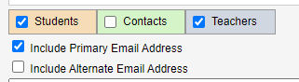
This is an important distinction if you have secondary students in your school i.e. Carihi students who are taking a course at Timberline.
When sending to contacts from the Student Top Tab, or the Gradebook Top Tab and you have the student roster on your screen, only the primary contacts with the ‘receive email’ box checked will receive the email-this is the situation you normally want!
The ‘Include Alternate Email Address’ includes the emails of contacts who may have 2 possible emails listed ie. Home (primary) and work (alternate).
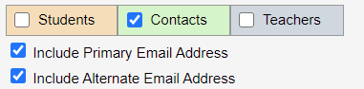
Student Top Tab>Contact Side Tab:
- When you send emails from here, using Options>send email, Emails sent from this screen will send to all contacts with a valid email address. It does not limit to only those with ‘receive email’ selected. Review the recipient box before you hit send and ‘x’ any emails that should not be receiving the email (i.e. emergency contacts).
- You can click on the blue hyperlink of the contacts email address to send an email through Outlook. The advantage to this method is that your email is then available in your ‘sent’ box.

Email limitations
- Subject line: limit of 200 characters
- Size: maximum combined size (if you have attachments) is 7.1 MB. Limit of 56 characters for the file name. It is recommended that you send links to documents and not send attachments. If the file is too big, the email will ‘time out’ and some of your recipients may receive it, but not all and it is impossible to tell who received it.
Email Log
- To view who has been sent your email and the text of the email, go to the Email Log:
Staff View>My Info Top Tab>email Log Side Tab. Use the filter menu to view the records for Today, This Week, This Month or All Records. Click on the blue hyper link date to see the message and the recipients. Note, this is a log of who was sent the email; it does not necessarily mean they received the email! Mass emails sent from MYEDBC can be rejected by the spam filtering on the recipients' mail account.

Distribution lists
- Do not use the Outlook distribution lists with the MyEd email (i.e. Penfield.staff@sd72.bc.ca). It will not recognize the individual accounts. You must enter the emails separately, with a comma (not a semi-colon) between addresses.

